Assignment No. 11 — Indexing and Query Optimization

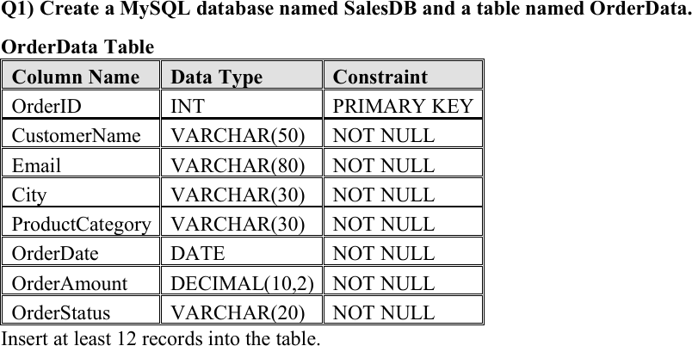

CREATE DATABASE SalesDB;

USE SalesDB;

CREATE TABLE OrderData ( OrderID INT PRIMARY KEY,
CustomerName VARCHAR(50) NOT NULL, Email VARCHAR(80) NOT NULL,
City VARCHAR(30) NOT NULL,
ProductCategory VARCHAR(30) NOT NULL, OrderDate DATE NOT NULL,
OrderAmount DECIMAL(10,2) NOT NULL,
OrderStatus VARCHAR(20) NOT NULL
);

INSERT INTO OrderData
(OrderID, CustomerName, Email, City, ProductCategory, OrderDate, OrderAmount, OrderStatus)

VALUES
(1, 'Rahul Sharma', 'rahul@gmail.com', 'Mumbai', 'Electronics', '2026-01-05', 55000.00, 'Delivered'), (2, 'Priya Patil', 'priya@gmail.com', 'Pune', 'Furniture', '2026-01-08', 32000.00, 'Delivered'), (3, 'Aman Verma', 'aman@gmail.com', 'Nashik', 'Clothing', '2026-01-12', 8500.00, 'Pending'),
(4, 'Sneha Joshi', 'sneha@gmail.com', 'Mumbai', 'Electronics', '2026-01-20', 72000.00, 'Delivered'), (5, 'Karan Mehta', 'karan@gmail.com', 'Thane', 'Furniture', '2026-02-03', 28000.00, 'Cancelled'), (6, 'Neha Shah', 'neha@gmail.com', 'Pune', 'Electronics', '2026-02-08', 48000.00, 'Delivered'), (7, 'Rohan Desai', 'rohan@gmail.com', 'Mumbai', 'Clothing', '2026-02-15', 12000.00, 'Pending'),
(8, 'Meera Kulkarni', 'meera@gmail.com', 'Nashik', 'Furniture', '2026-02-22', 36000.00, 'Delivered'), (9, 'Arjun Nair', 'arjun@gmail.com', 'Thane', 'Electronics', '2026-03-02', 64000.00, 'Shipped'), (10, 'Divya More', 'divya@gmail.com', 'Mumbai', 'Furniture', '2026-03-07', 41000.00, 'Delivered'), (11, 'Isha Singh', 'isha@gmail.com', 'Pune', 'Clothing', '2026-03-12', 15000.00, 'Shipped'),
(12, 'Om Jadhav', 'om@gmail.com', 'Mumbai', 'Electronics', '2026-03-18', 59000.00, 'Pending');

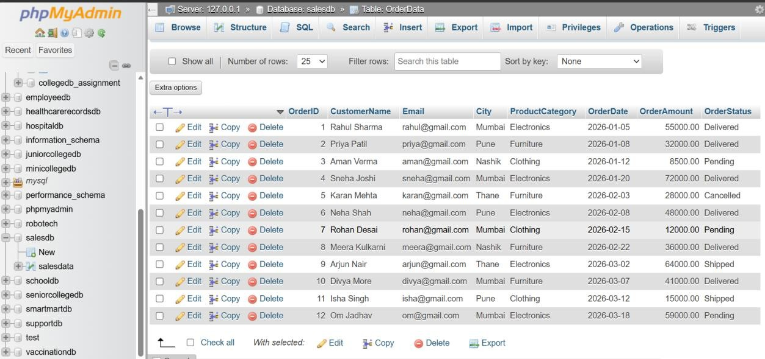

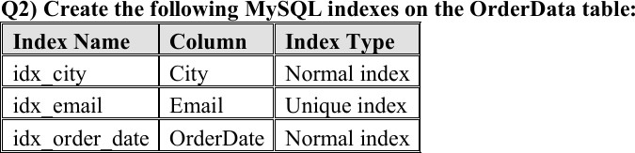

CREATE INDEX idx_city ON OrderData(City);

CREATE UNIQUE INDEX idx_email ON OrderData(Email);

CREATE INDEX idx_order_date ON OrderData(OrderDate);

SHOW INDEX FROM OrderData;

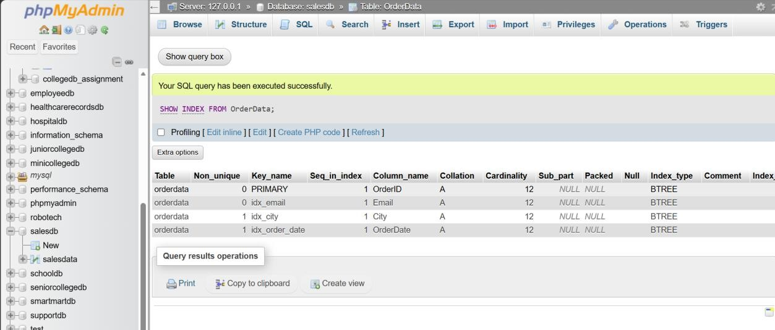

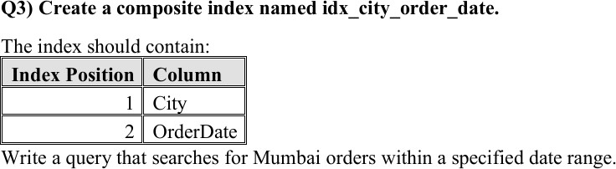

CREATE INDEX idx_city_order_date ON OrderData(City, OrderDate);

SELECT *
FROM OrderData WHERE City = 'Mumbai'
AND OrderDate BETWEEN '2026-02-01' AND '2026-03-31';

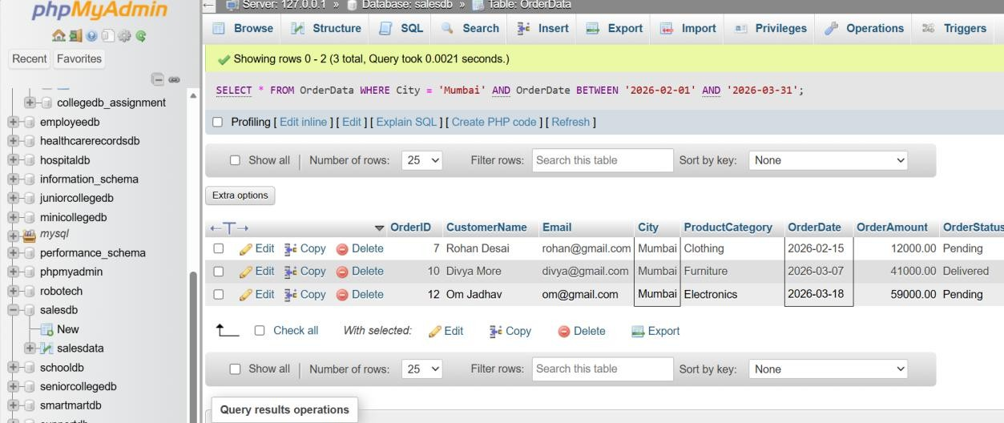

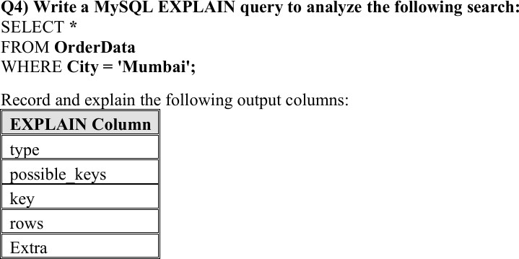

EXPLAIN SELECT *
FROM OrderData WHERE City = 'Mumbai';

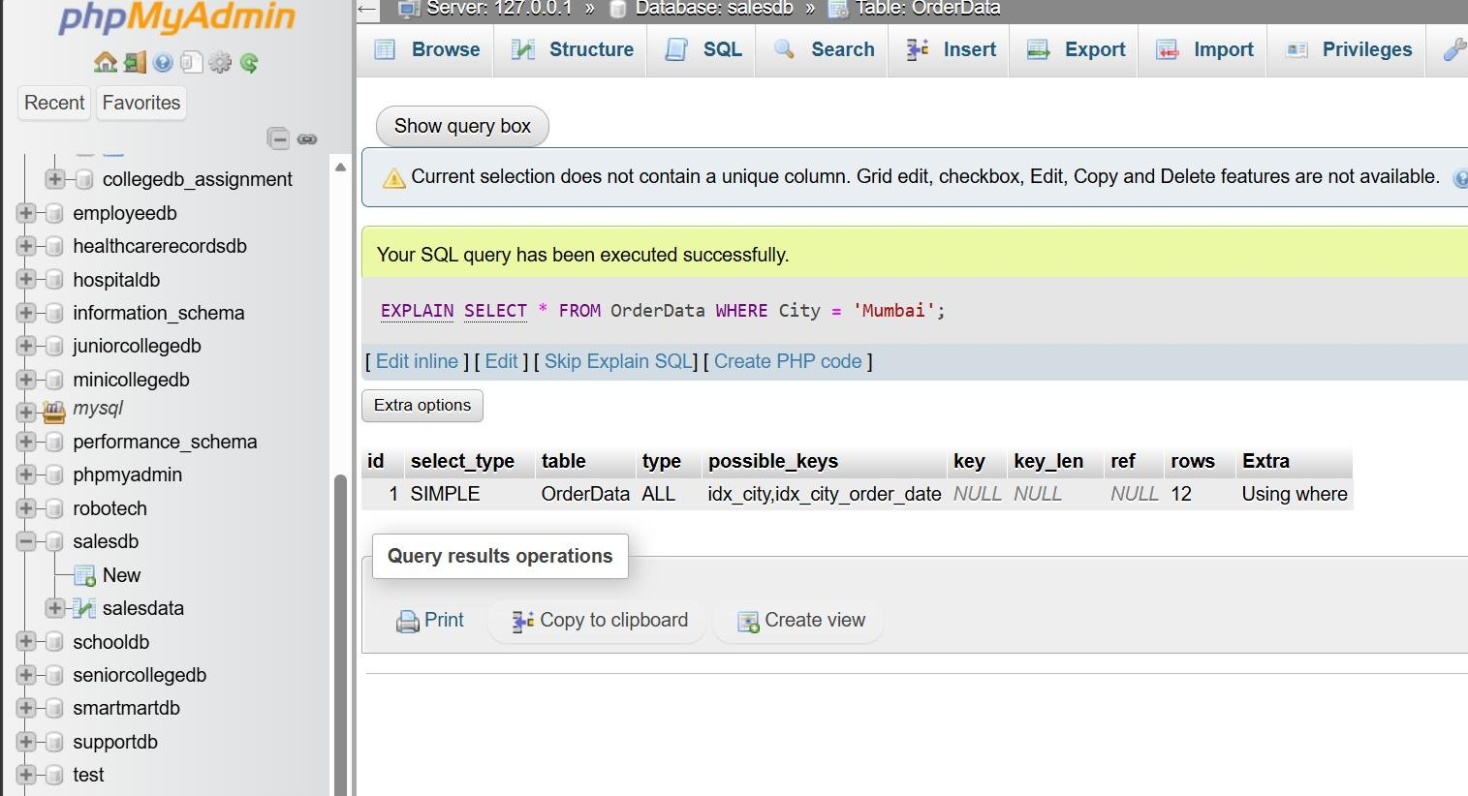

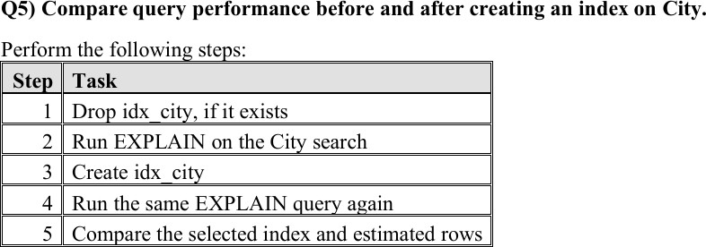

DROP INDEX idx_city ON OrderData;

EXPLAIN SELECT *
FROM OrderData WHERE City = 'Mumbai';

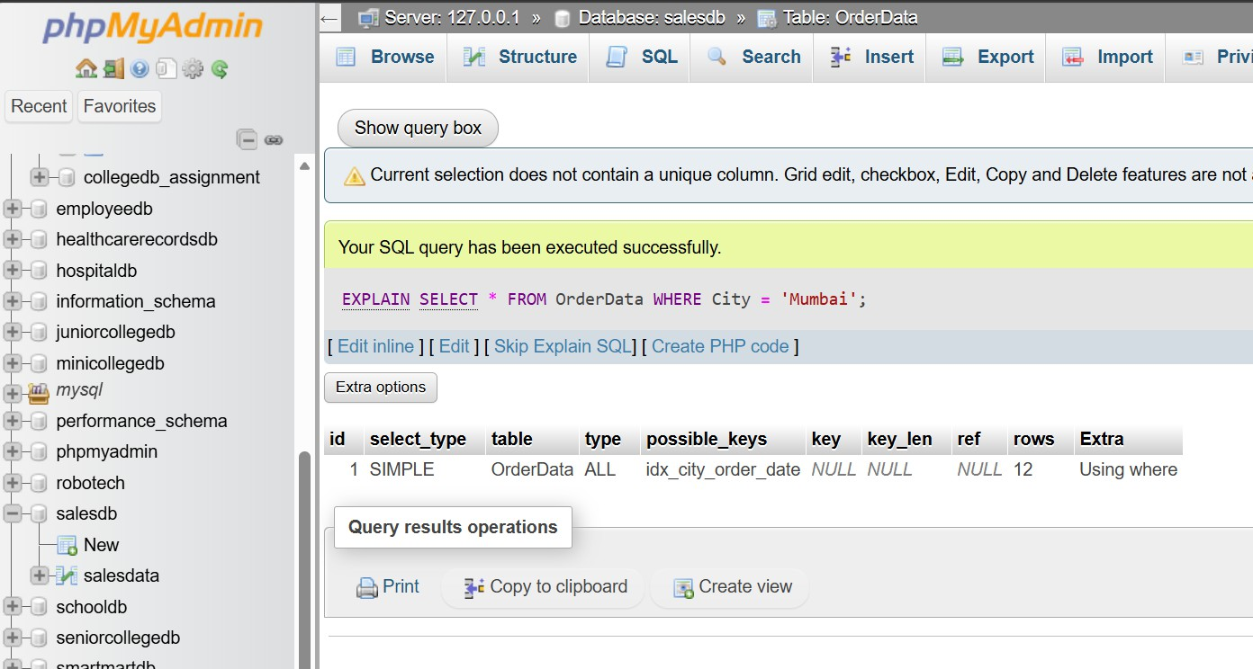
CREATE INDEX idx_city ON OrderData(City);

EXPLAIN SELECT *
FROM OrderData WHERE City = 'Mumbai';

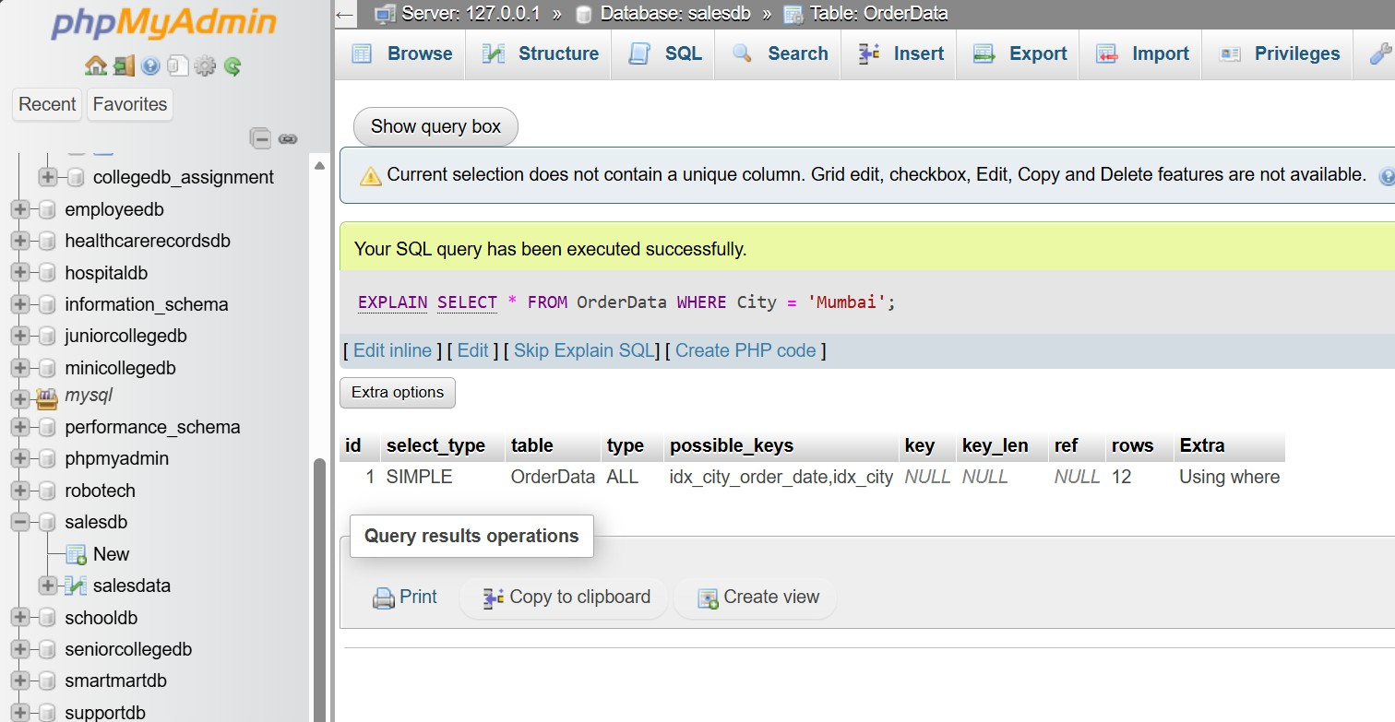

Q6) Rewrite the following query in a more index-friendly form: SELECT * FROM OrderData WHERE YEAR(OrderDate) = 2026;

SELECT *
FROM OrderData
WHERE YEAR(OrderDate) = 2026;
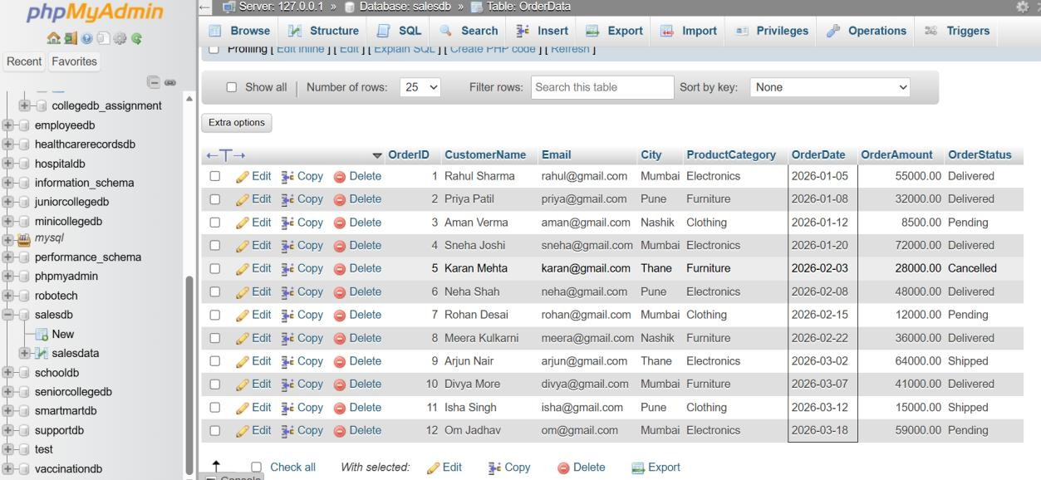

SELECT
OrderID, CustomerName, OrderDate, OrderAmount
FROM OrderData
WHERE OrderDate >= '2026-01-01' AND OrderDate < '2027-01-01';
